
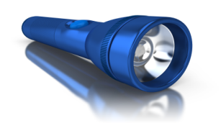
Torch far away
Pencil close
Torch low down
Torch high up

